**How to use the iQ video upload tool**

**Introduction**:

The purpose of the video upload tool is to read the *manifest.iq* file created using the manifest generation tool, and then update the video database with the details from the manifest file and finally copy the videos to the iQ system content folder.

**Prerequisites**:

* The ***videoupload*** tool must be run on the iQ system
* The iQ system should have python version 2.7.x (verify by entering the following console command ‘*python --version’*)
* The videos must all be in a single source directory
* The source directory must contain the *manifest.iq* file created by the manifest generation tool

**Upload video(s) to the iQ system**

1. Run ***videoupload***



1. You will then be prompted for the path to the folder containing the videos



1. Enter the path. For example ***/media/PENDRIVE/video***



1. Press ENTER, the system will update the database and upload the videos to the system and finally display the results.

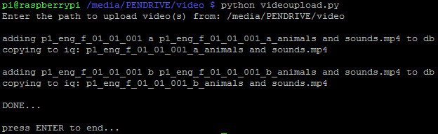

1. Press enter to end the program.